ABOUT CCNA
CCNA is the acronym for the Cisco Certified Network Associate certification from Cisco. In speech and in writing, this certification is properly referred to by the initials CCNA rather than the full name.
CCNA certification is a second-level Cisco Career certification that indicates a foundation in apprentice knowledge of networking. CCNA certification validates the ability to install, configure, operate, and troubleshoot medium-size routed and switched networks, including implementation and verification of connections to remote sites in a WAN
To become a CCNA, a passing score on the 640-802 exams must be achieved, or combined passing scores on both the ICND1 640-822 and ICND2 640-816 exams. Passing the ICND1 grants you the Cisco Certified Entry Networking Technician (CCENT). Passing scores are set by using statistical analysis and are subject to change. At the completion of the exam, candidates receive a score report along with a score breakout by exam section and the passing score for the given exam. Cisco does not publish exam passing scores because exam questions and passing scores are subject to change without notice.

ROUTERS
router is a networking device whose software and hardware are usually tailored to the tasks of routing and forwarding information. For example, on the Internet, information is directed to various paths by routers.
Routers connect two or more logical subnets, which do not necessarily map one-to-one to the physical interfaces of the router.The term "layer 3 switch" often is used interchangeably with router, but switch is a general term without a rigorous technical definition. In marketing usage, it is generally optimized for Ethernet LAN interfaces and may not have other physical interface types. In comparison, a network hub does not do any routing, instead every packet it receives on one network line gets forwarded to all the other network lines.

Types of routers
Routers may provide connectivity inside enterprises, between enterprises and the Internet, and inside Internet Service Providers (ISP). The largest routers (for example the Cisco CRS-1 or Juniper T1600) interconnect ISPs, are used inside ISPs, or may be used in very large enterprise networks. The smallest routers provide connectivity for small and home offices.

Routers for Internet connectivity and internal use
Routers intended for ISP and major enterprise connectivity will almost invariably exchange routing information with the Border Gateway Protocol (BGP). RFC 4098 defines several types of BGP-speaking routers:
- Edge Router: Placed at the edge of an ISP network, it speaks external BGP (eBGP) to a BGP speaker in another provider or large enterprise Autonomous System (AS).
- Subscriber Edge Router: Located at the edge of the subscriber's network, it speaks eBGP to its provider's AS(s). It belongs to an end user (enterprise) organization.
- Inter-provider Border Router: Interconnecting ISPs, this is a BGP speaking router that maintains BGP sessions with other BGP speaking routers in other providers' ASes.
- Core router: A router that resides within the middle or backbone of the LAN network rather than at its periphery.
Within an ISP: Internal to the provider's AS, such a router speaks internal BGP (iBGP) to that provider's edge routers, other intra-provider core routers, or the provider's inter-provider border routers.
"Internet backbone:" The Internet does not have a clearly identifiable backbone, as did its predecessors. See default-free zone (DFZ). Nevertheless, it is the major ISPs' routers that make up what many would consider the core. These ISPs operate all four types of the BGP-speaking routers described here. In ISP usage, a "core" router is internal to an ISP, and used to interconnect its edge and border routers. Core routers may also have specialized functions in virtual private networks based on a combination of BGP and Multi-Protocol Label Switching (MPLS)
Routers are also used for port forwarding for private servers.

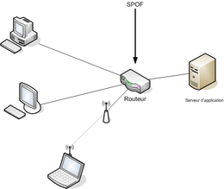

INTERNETWORKING OVERVIEW
In this we learnt that,
Line configuration is the manner in which the devices are attached to the communication links.
Two types of line configuration are:
- Point to point
- Multipoint
Topology : it is the way in which the devices are connected together in the network.
These are:
- Bus
- Star
- Ring
- Tree
- Mesh
BUS
In computer architecture, a bus is a subsystem that transfers data between computer components inside a computer or between computers.
Early computer buses were literally parallel electrical buses with multiple connections, but the term is now used for any physical arrangement that provides the same logical functionality as a parallel electrical bus. Modern computer buses can use both parallel and bit-serial connections, and can be wired in either a multidrug (electrical parallel) or daisy chain topology, or connected by switched hubs, as in the case of USB.

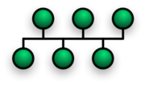

STAR
Star networks are one of the most common computer network topologies. In its simplest form, a star network consists of one central switch, hub or computer, which acts as a conduit to transmit messages. Thus, the hub and leaf nodes, and the transmission lines between them, form a graph with the topology of a star. If the central node is passive, the originating node must be able to tolerate the reception of an echo of its own transmission, delayed by the two-way transmission time (i.e. to and from the central node) plus any delay generated in the central node. An active star network has an active central node that usually has the means to prevent echo-related problems.
The star topology reduces the chance of network failure by connecting all of the systems to a central node. When applied to a bus-based network, this central hub rebroadcasts all transmissions received from any peripheral node to all peripheral nodes on the network, sometimes including the originating node. All peripheral nodes may thus communicate with all others by transmitting to, and receiving from, the central node only. The failure of a transmission line linking any peripheral node to the central node will result in the isolation of that peripheral node from all others, but the rest of the systems will be unaffected.
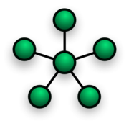
Ring
A ring network is a network topology in which each node connects to exactly two other nodes, forming a single continuous pathway for signals through each node - a ring. Data travels from node to node, with each node along the way handling every packet.
Because a ring topology provides only one pathway between any two nodes, ring networks may be disrupted by the failure of a single link. A node failure or cable break might isolate every node attached to the ring. FDDI networks overcome this vulnerability by sending data on a clockwise and a counterclockwise ring: in the event of a break data is wrapped back onto the complementary ring before it reaches the end of the cable, maintaining a path to every node along the resulting "C-Ring". 802.5 networks -- also known as IBM Token Ring networks -- avoid the weakness of a ring topology altogether: they actually use a star topology at the physical layer and a Multistation Access Unit to imitate a ring at the datalink layer.
Many ring networks add a "counter-rotating ring" to form a redundant topology. Such "dual ring" networks include Spatial Reuse Protocol, Fiber Distributed Data Interface (FDDI), and Resilient Packet Ring
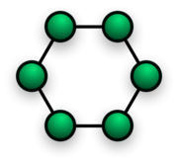

Tree
The type of network topology in which a central 'root' node (the top level of the hierarchy) is connected to one or more other nodes that are one level lower in the hierarchy (i.e., the second level) with a point-to-point link between each of the second level nodes and the top level central 'root' node, while each of the second level nodes that are connected to the top level central 'root' node will also have one or more other nodes that are one level lower in the hierarchy (i.e., the third level) connected to it, also with a point-to-point link, the top level central 'root' node being the only node that has no other node above it in the hierarchy (The hierarchy of the tree is symmetrical.)
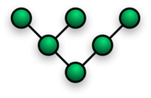

Mesh
The value of fully meshed networks is proportional to the exponent of the number of subscribers, assuming that communicating groups of any two endpoints, up to and including all the endpoints, is approximated by Reeds law.
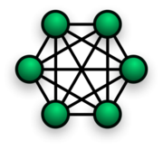
Fully connected
The type of network topology in which each of the nodes of the network is connected to each of the other nodes in the network with a point-to-point link – this makes it possible for data to be simultaneously transmitted from any single node to all of the other nodes.
Note: The physical fully connected mesh topology is generally too costly and complex for practical networks, although the topology is used when there are only a small number of nodes to be interconnected.
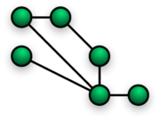

Partially connected
The type of network topology in which some of the nodes of the network are connected to more than one other node in the network with a point-to-point link – this makes it possible to take advantage of some of the redundancy that is provided by a physical fully connected mesh topology without the expense and complexity required for a connection between every node in the network.
Note: In most practical networks that are based upon the physical partially connected mesh topology, all of the data that is transmitted between nodes in the network takes the shortest path (or an approximation of the shortest path) between nodes, except in the case of a failure or break in one of the links, in which case the data takes an alternate path to the destination. This requires that the nodes of the network possess some type of logical 'routing' algorithm to determine the correct path to use at any particular time

The types of network are:
- LAN
- MAN
- WAN
- CAN
LAN
A local area network (LAN) is a computer network covering a small physical area, like a home, office, or small group of buildings, such as a school, or an airport. The defining characteristics of LANs, in contrast to wide-area networks (WANs), include their usually higher data-transfer rates, smaller geographic place, and lack of a need for leased telecommunication lines.
ARCNET, Token Ring and many other technologies have been used in the past, and G.hn may be used in the future, but Ethernet over twisted pair cabling, and Wi-Fi are the two most common technologies currently in us
MAN
Metropolitan area networks, or MANs, are large computer networks usually spanning a city. They typically use wireless infrastructure or Optical fiber connections to link their sites.

The IEE 802-2001 standard describes a MAN as being:
A MAN is optimized for a larger geographical area than a LAN, ranging from several blocks of buildings to entire cities. MANs can also depend on communications channels of moderate-to-high data rates. A MAN might be owned and operated by a single organization, but it usually will be used by many individuals and organizations. MANs might also be owned and operated as public utilities. They will often provide means for internetworking of local networks. Metropolitan area networks can span up to 50km, devices used are modem and wire/cable

WAN
Wide Area Network (WAN) is a computer network that covers a broad area (i.e., any network whose communications links cross metropolitan, regional, or national boundaries. This is in contrast with personal area networks (PANs), local area networks (LANs), campus area networks (CANs), or metropolitan area networks (MANs) which are usually limited to a room, building, campus or specific metropolitan area (e.g., a city) respectively. The largest and most well-known example of a WAN is the Internet.

CAN
campus area network (CAN) is a computer network that interconnects local area networks throughout a limited geographical area, such as a university campus, a corporate campus, or a military base. It could be considered a metropolitan area network that is specific to a campus setting. A campus area network is, therefore, larger than a local area network but smaller than a wide area network. The term is sometimes used to refer to university campuses, while the term corporate area network is used to refer to corporate campuses instead.

Modes of transmission:
- Simplex
- Duplex
- Full duplex
OSI : The open system Interconnection is the layered model for the network systems, which enables computers in the network to communicate with each other.
The seven layers of the OSI model :
- Application
- Presentation
- Session
- Transport
- Network
- Data link
- Physical
UTP Connections: The cables used for cabling the RJ-45 connect are, Straight-Through Cables, Cross-Over Cables and Twisted Pair Cables.
Two types of cables can be used with Ethernet LAN interfaces:
  - A straight-through, or patch cable, with the order of the colored pins the same on each end of the cable
  - A crossover cable, with pin 1 connected to pin 3, and pin 2 connected to pin 6
Straight-through cables are used for:
  - Switch-to-router
  - Switch-to-PC
  - Hub-to-PC
  - Hub-to-server
Crossover cables are used for:
  - Switch-to-switch
  - PC-to-PC
  - Switch-to-hub
10) Hub-to-hub
11) Router-to-router
12) Router-to-server

IP ADDRESSING
Classification of IP addresses
- Class A : consists of a an 8 bit network number and a 24 bit network bit host number. Its range from 1 to 126. Addresses beginning with 127 are reserved for loopback addressing. IP address 0.0.0.0 is reserved and not included as a Class A IP address.
- Class B: Consists of a 16 bit network number and a 16 bit host number. Class B IP addresses range from 128 to 191 decimals.
- Class C: Consists of a 8 bit network number and a 24 bit host number. Class C IP addresses range from 192 to 223 decimals.
- Class D: Consists of multicast addresses. Multicasting is a produced by which the data packets can be sent to selected recipients over the network. Range from 224 to 239.
- Class E: Known as reserved IP addresses . Range from 240 to 255.
Subnet Mask
A subnet mask is basically used to identify the network bits and host bits I the IP address.
The Subnet mask starting with the bit 0 or ending with the bit 1.

How to calculate network and host requirements using the following formulae:
2 power x => numbers of networks, where X refers to number of subnet bits.
2 power Y => hosts on largest segment ,where Y represent the host bit.
X + Y <= total host bits.

Assembling and cabling Cisco Devices
ROM is a form of permanent storage. Cisco devices use ROM to store:
  - The bootstrap instructions
  - Basic diagnostic software
  - Scaled-down version of IOS
Flash Memory
  - Flash memory does not lose its contents when the router loses power or is restarted.

The output from the show version command includes:
IOS version
  - Cisco Internetwork Operating System Software
  - IOS (tm) C2600 Software (C2600-I-M), Version 12.2(28), RELEASE SOFTWARE (fc5)
  - This is the version of the Cisco IOS software in RAM and that is being used by the router.
ROM Bootstrap Program
  - ROM: System Bootstrap, Version 12.1(3r)T2, RELEASE SOFTWARE (fc1)
  - This shows the version of the system bootstrap software, stored in ROM memory, that was initially used to boot up the router.
Location of IOS
  - System image file is "flash:c2600-i-mz.122-28.bin"
  - This shows where the bootstrap program is located and loaded the Cisco IOS, and the complete filename of the IOS image.
CPU and Amount of RAM
  - cisco 2621 (MPC860) processor (revision 0x200) with 60416K/5120K bytes of memory

Interfaces
  - 2 FastEthernet/IEEE 802.3 interface(s)
  - 2 Low-speed serial(sync/async) network interface(s)
  - This section of the output displays the physical interfaces on the router. In this example, the Cisco 2621 router has two FastEthernet interfaces and two low-speed serial interfaces.
Amount of NVRAM
  - 32K bytes of non-volatile configuration memory.
This is the amount of NVRAM on the router. NVR
Amount of Flash
  - 16384K bytes of processor board System flash (Read/Write)
Configuration Register
  - Configuration register is 0x2102
The last line of the show version command displays the current configured value of the software configuration register in hexadecimal

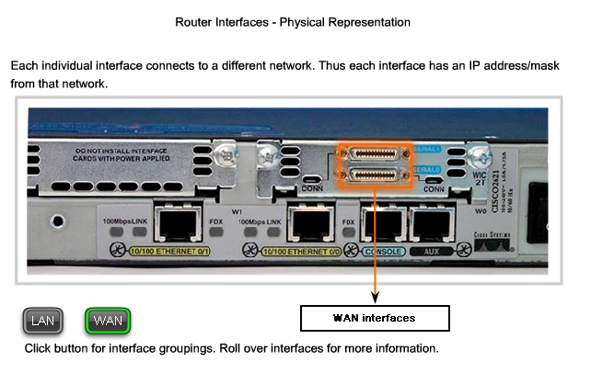

How we can we configure on live router or on Boson software:

- Password can be configured for entering privileged EXEC mode. Router(config)#enable secret class
- Passwords can also be configured for the console and Telnet lines. The command login enables password checking on the line. If you do not enter the command login on the console line, the user will be granted access to the line without entering a password.
- R1(config)#line console 0
- R1(config-line)#password cisco
- R1(config-line)#login
- R1(config-line)#exit
- R1(config)#line vty 0 4
- R1(config-line)#password cisco
- R1(config-line)#login
- R1(config-line)#exit
OUTCOME:
- The outcome of entering these commands
R1(config)# line vty 0 4
R1(config-line)# password check123
R1(config-line)# login
- sets the password to be used for connecting to this router via Telnet

- R1#show startup-config
- This command displays the startup configuration file stored in NVRAM. This is the configuration that the router will use on the next reboot. This configuration does not change unless the current running configuration is saved to NVRAM with the copy running-config startup-config command.

IP ROUTING
- The routing of data packets from one network segment to another
  - For example from from one subnet to another subnet
- A router (gateway) is often involved in the routing process

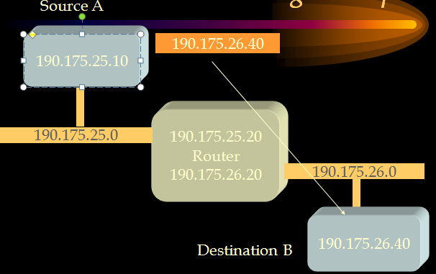
- Computer A will analyze (AND)the data packet against its subnet masks
  - The data is to be sent to another subnet
- Broadcast for the hardware address (eg: CC) of the gateway (IP address is already known)
  - Using ARP
- On receiving the hardware address, send the data packet to the gateway (router) to be forwarded to its destination subnet
- The router will now be able to deliver the data packet to its destination in the other subnet
- An analysis of the data packet (ANDing) will determine the destination subnet
- The gateway will broadcast for the hardware address of the receiving host (IP already known)
- On receiving a response, the packet will be forwarded to the destination host
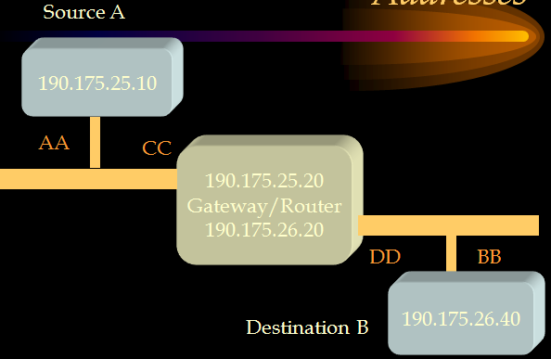

Major Routing Methods:
- Static routing
  - Routing tables are hand maintained at the router
- Dynamic routing
  - Routing tables are dynamically maintained by the routing protocol
  - RIP (Routing Information Protocol)
  - Open Shortest Path First (OSPF) protocol
- Static and dynamic routings may be integrated
Entries in to routing table:
- Network ID (Address)
- Network (subnet) mask
- Next hop (Gateway address)
- Interface
  - Network interface for forwarding the data packet
- Metric
  - Cost of each route for the selection of the best hop
Dynamic Routing Protocols I
RIP
Autonomous Systems:
- An autonomous system is a region of the Internet that is administered by a single entity.
- Examples of autonomous regions are:
    - UVA’s campus network
    - MCI’s backbone network
    - Regional Internet Service Provider
    - Routing is done differently within an autonomous system (intradomain routing) and between autonomous system (interdomain routing).

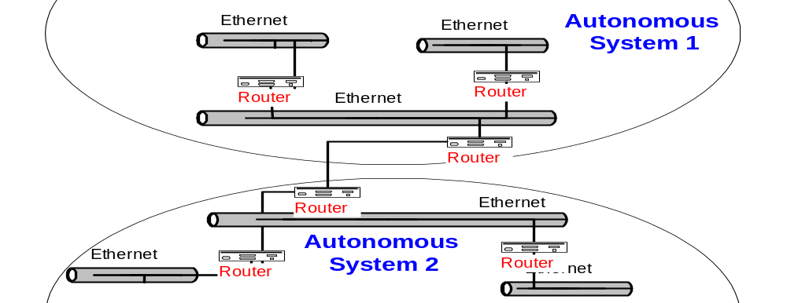

Intradomain:
Intradomain Routing
- Routing within an AS
- Ignores the Internet outside the AS
- Protocols for Intradomain routing are also called Interior Gateway Protocols or IGP’s.
- Popular protocols are
  - RIP (simple, old)
  - OSPF (better)
Interdomain Routing
Interdomain Routing
- Routing between AS’s
- Assumes that the Internet consists of a collection of interconnected AS’s
- Normally, there is one dedicated router in each AS that handles interdomain traffic.
- Protocols for interdomain routing are also called Exterior Gateway Protocols or EGP’s.
- Routing protocols:
  - EGP
  - BGP (more recent)

Approaches to Shortest Path Routing
- There are two basic routing algorithms found on the Internet.
1. Distance Vector Routing
- Each node knows the distance (=cost) to its directly connected neighbors
- A node sends periodically a list of routing updates to its neighbors.
- If all nodes update their distances, the routing tables eventually converge
- New nodes advertise themselves to their neighbors
2. Link State Routing
- Each node knows the distance to its neighbors
- The distance information (=link state) is broadcast to all nodes in the network
- Each node calculates the routing tables independently

What Is Enhanced IGRP (EIGRP)?
- Enhanced IGRP supports:
  - Rapid convergence
  - Reduced bandwidth usage
  - Multiple network-layer support
  - Uses Diffused Update Algorithm (DUAL) to select loop-free routes and enable fast convergence
Up to six unequal paths to a remote network (4 by default
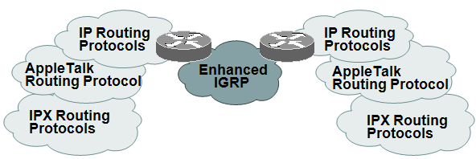

Configuring EIGRP for IP
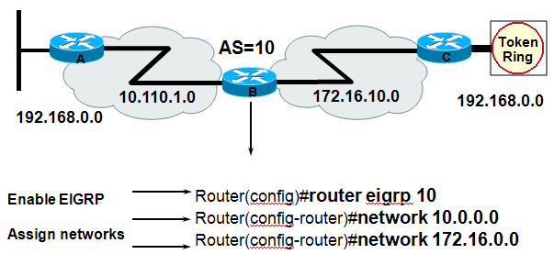
If you use the same AS number for EIGRP as IGRP, EIGRP will automatically redistribute IGRP into EIGRP.

Introducing OSPF
  - Open standard
  - Shortest path first (SPF) algorithm
  - Link-state routing protocol (vs. distance vector)
  - Can be used to route between AS’s
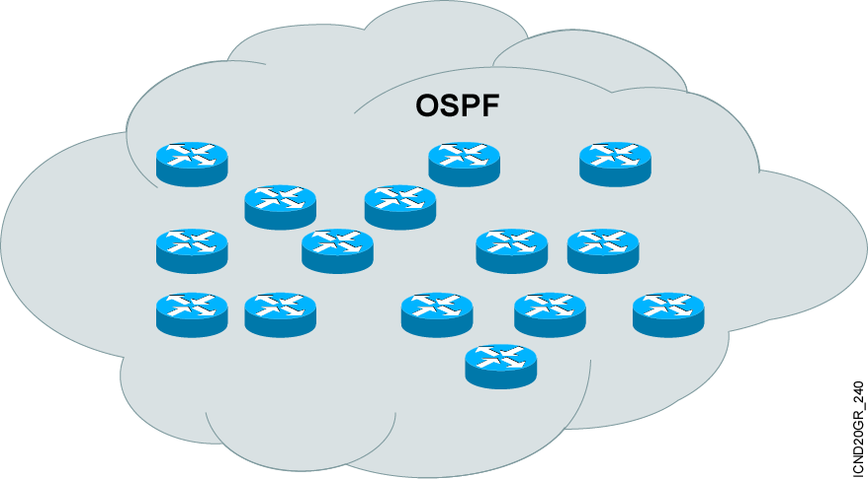
Types of OSPF Routers
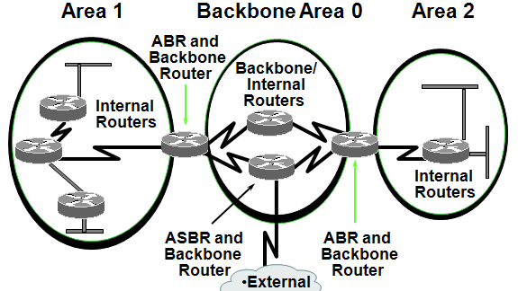
OSPF Example
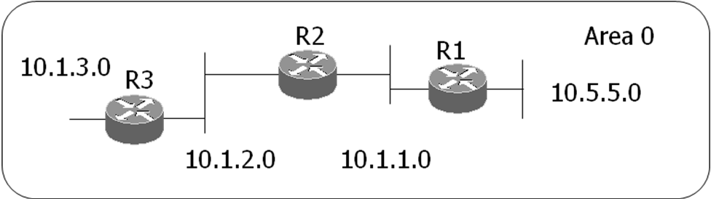
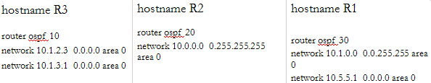
Configuring Wildcards
If we want to advertise a partial octet (subnet), we need to use wildcards.
  - 0.0.0.0 means all octets match exactly
  - 0.0.0.255 means that the first three match exactly, but the last octet can be any value
Access Control Lists (ACLs)
- List of conditions to test the traffic
- Router can permit or deny( like a filter)
- Provides Security
- Bandwidth Management
- Come in two Types
  - STANDARD and EXTENDED
What is ACL?
- A List of Criteria to which all Packets are compared.
  - Is this Packet from Network 10.5.2.0
    - Yes - Forward the Packet
    - No - Check with Next Statement
  - Is this a Telnet Protocol Packet from 25.25.0.0
    - Yes - Forward the Packet
    - No - Check Next Statement
  - Deny All Other Traffic
ACL Operations
- Packets are compared to Each Statement in an Access-list SEQUENTIALLY- From the Top Down.
- The sooner a decision is made the better.
- Well written Access-lists take care of the most abundant type of traffic first.
- All Access-lists End with an Implicit Deny All statement

Standard ACL
- Are given a # from 1-99
- Filtering based only on Source Address
Should be applied closest to the Destination

Extended ACL
- Are given a # from 100-199
- Much more flexible and complex
- Can filter based on:
  - Source address
  - Destination address
  - Session Layer Protocol (ICMP, TCP, UDP..)
  - Port Number (80 http, 23 telnet…)
- Should be applied closest to the Source

Implementing ACLs
- Step 1 - Create the Access-list
- Step 2 -Apply the Access-list to an Interface
  - Must be in interface config mode (config-if)#
  - IP access-group # in/out (routers point of view)
- Remember the Implicit Deny All at the end of each access-list.
- Two Approaches:
  - 1. List the traffic you know you want to permit
Deny all other traffic
  - 2. List the traffic you want to deny
Permit all other traffic (permit any)
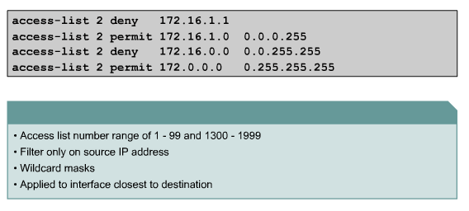
A(config)#access-list 5 deny 172.22.5.2 0.0.0.0
A(config)#access-list 5 deny 172.22.5.3 0.0.0.0
A(config)#access-list 5 permit any
So what does this access list do?
- Deny any host 172.22.5.2
- Deny any host 172.22.5.3
- All other traffic can go

- A(config)#access-list 5 deny 172.22.5.2 0.0.0.0
- A(config)#access-list 5 deny 172.22.5.3 0.0.0.0
- A(config)#access-list 5 permit any
- A(config)#access-list 5 deny 172.22.5.4 0.0.0.0

Why does the last line have no affect?
How could we correct this situation?
Extended ACL
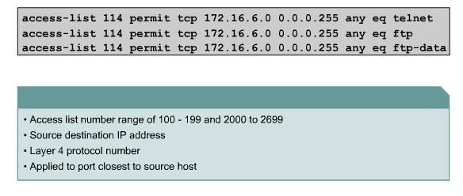
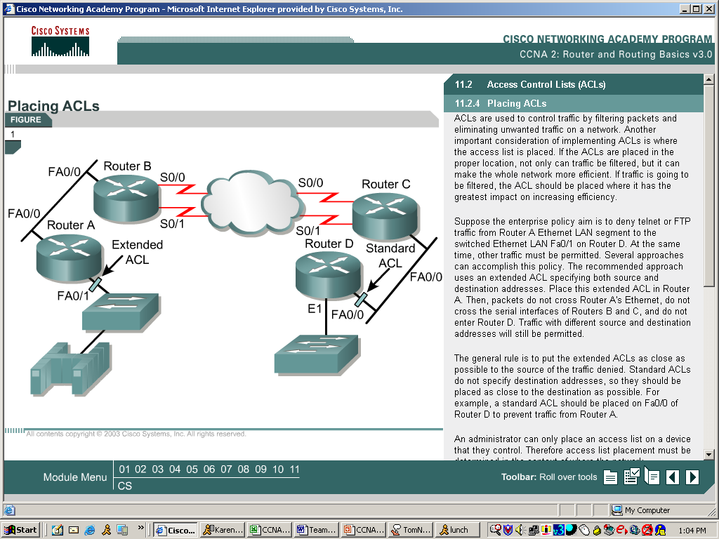
Standard : Closed to source
Extended: Closed to destination
Restricted ACL access
